# Cloud Computing Assignment 2

Adithya Chandrashekar - 1000990558

Kailash Havildar – 1000996588

## Temperature Readings

### Reading for 1 mapper 1 reducer : 42048 ms

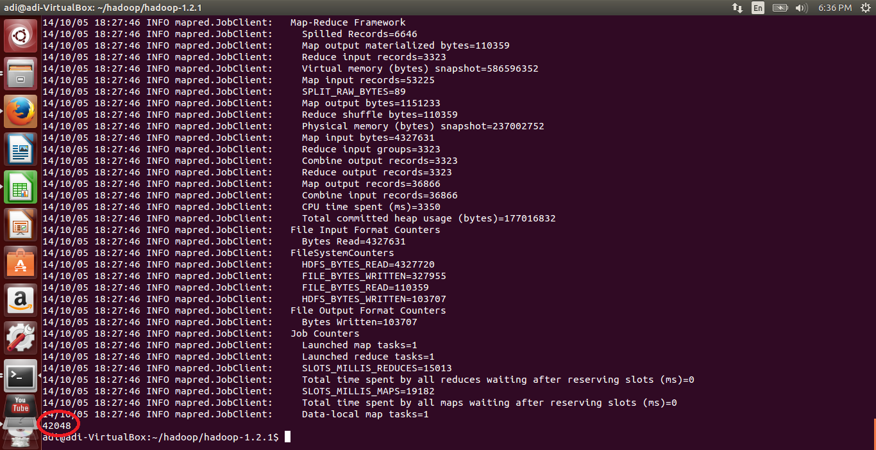

### Reading for 2 mapper 1 reducer – 49301 ms

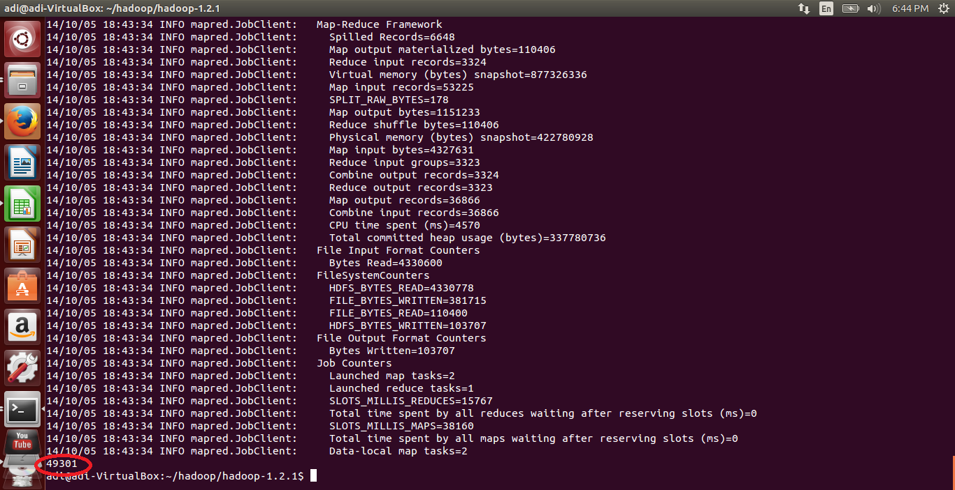

### Reading for 2 mappers 2 reducers – 53497 ms

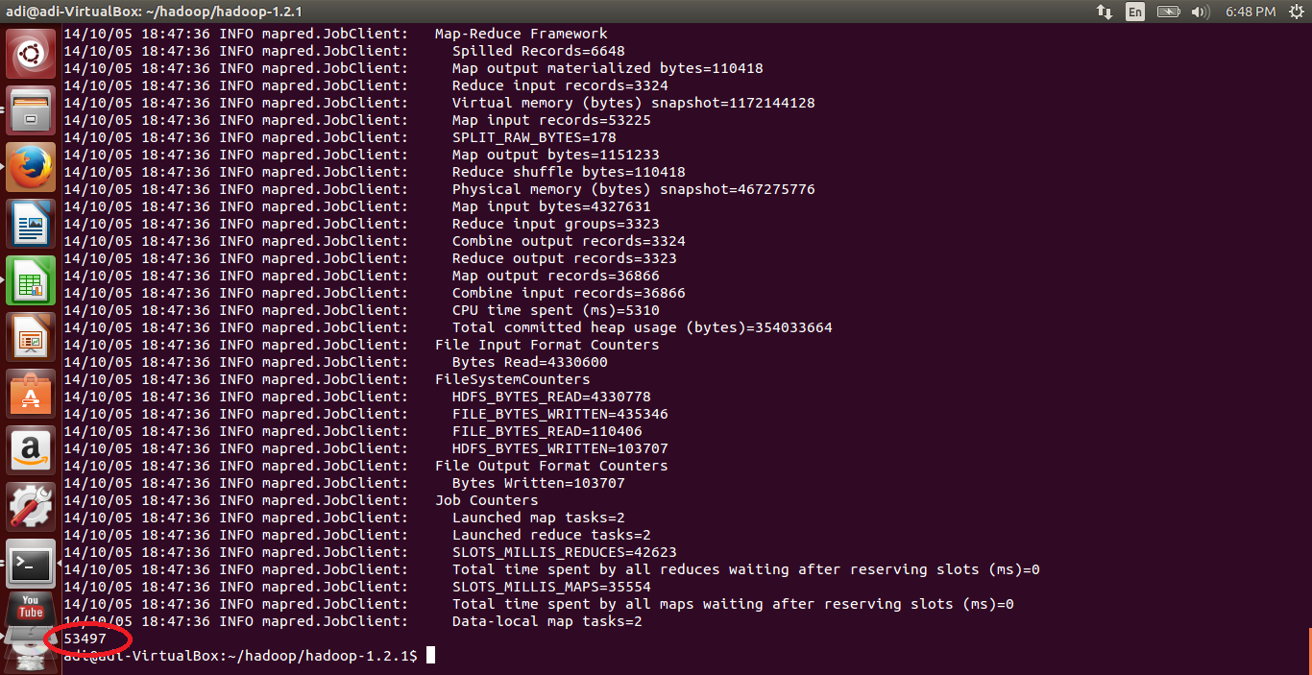

### Reading for 10 mappers 1 reducer – 109549 ms

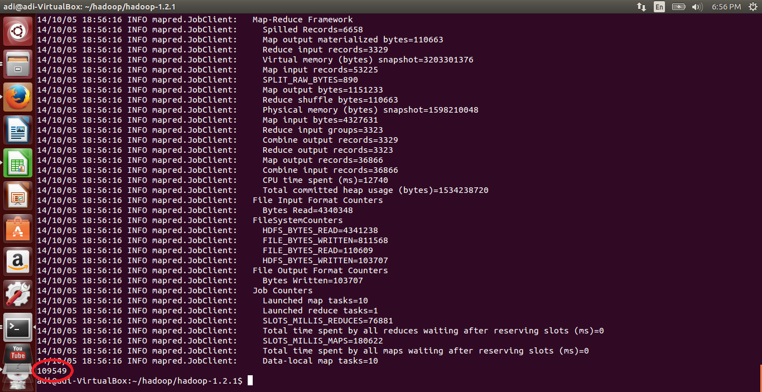

### Reading for 10 mappers 2 reducers – 114852 ms

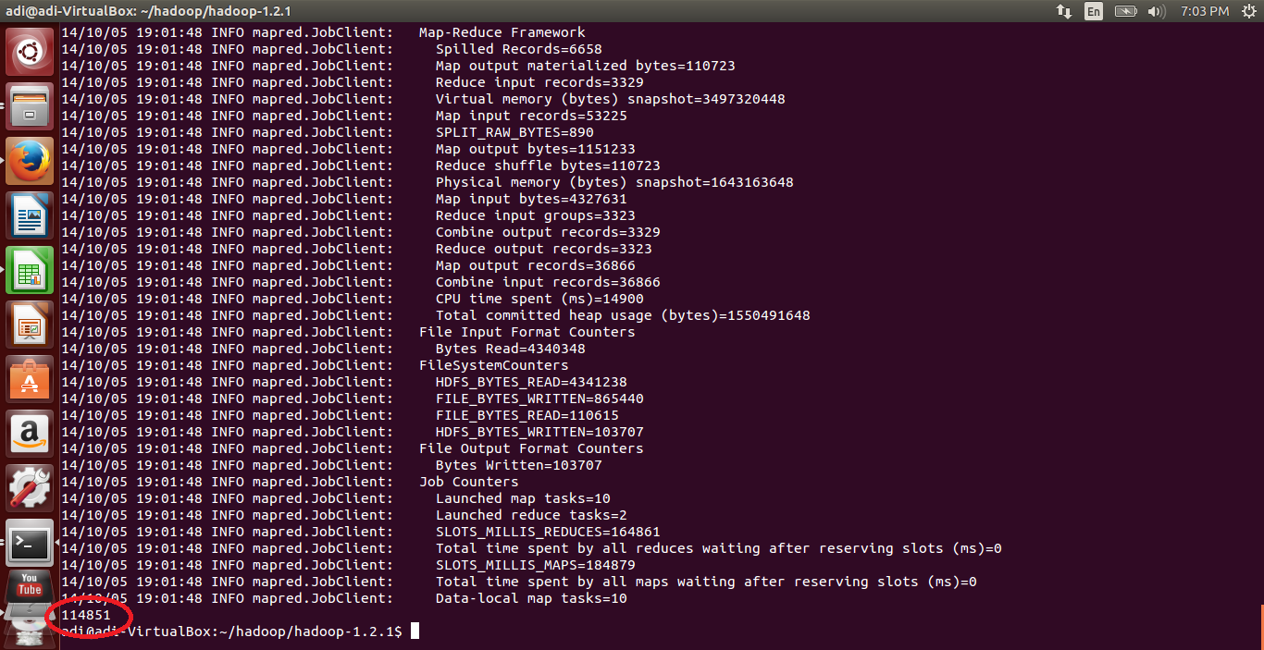

## Precipitation Readings

### Readings for 1 mapper 1 reducer – 39032 ms

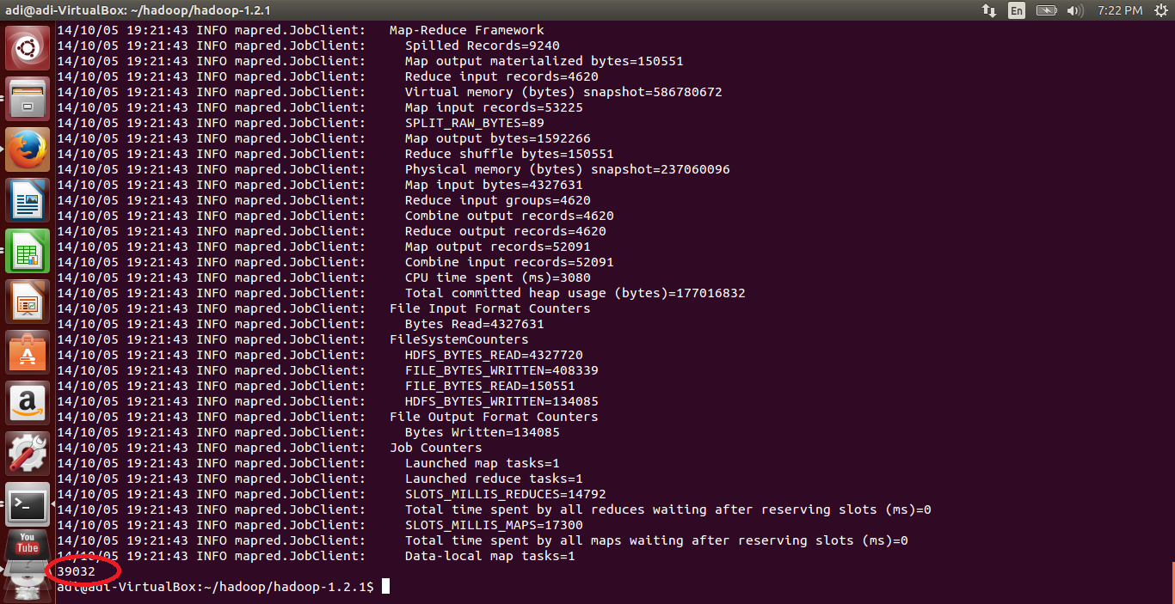

### Readings for 2 mappers 1 reducers – 45689

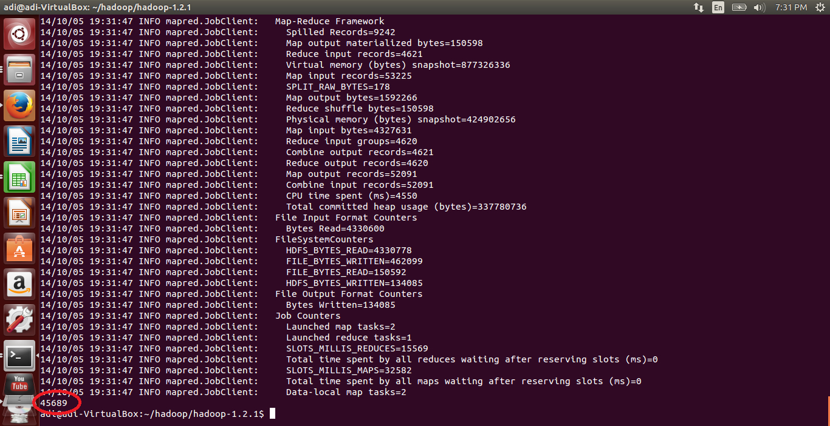

### Readings for 2 mappers 2 reducers – 55827 ms

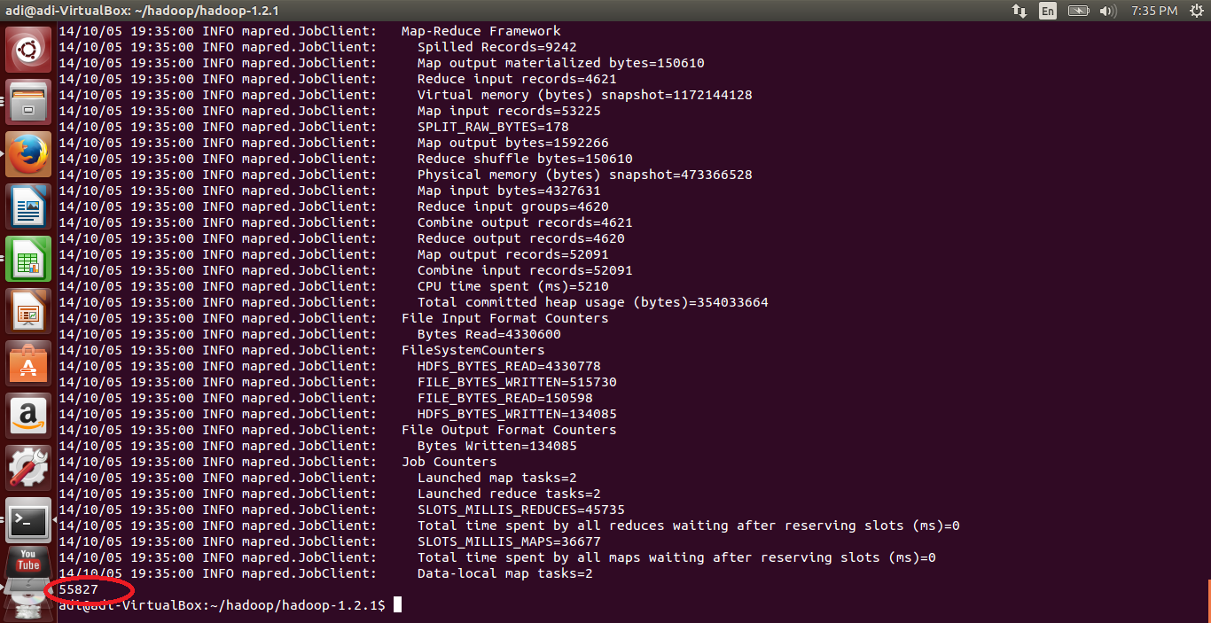

### Readings for 10 mappers 2 reduce – 104420 ms

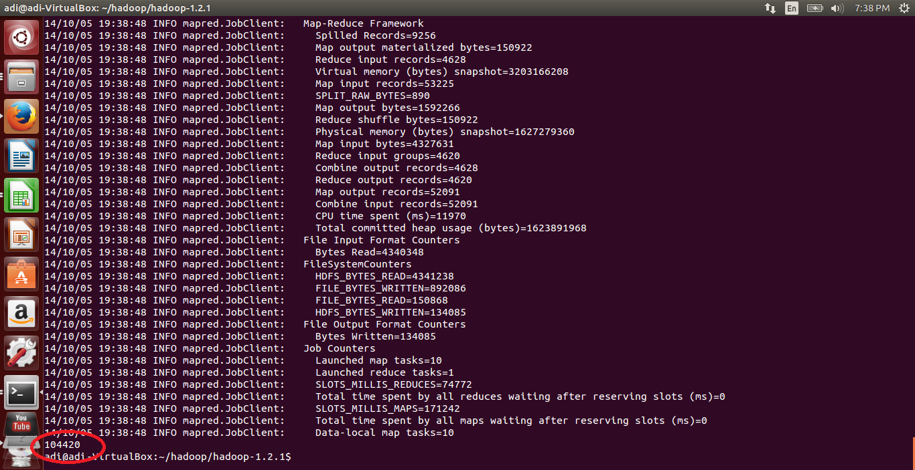

### Readings for 10 mappers 2 reducers – 123135 ms

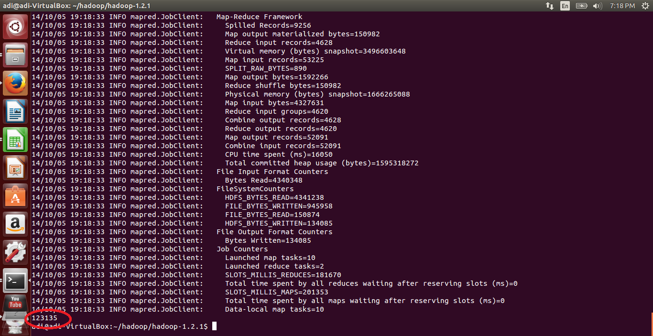

**Annual Montly temperature and Precipitation vs years for Abingdon, S Virginia, USA**

**Temperature and precipitation are varying unevenly over the years as you can see in the graph.**

# References:

<http://cs.smith.edu/dftwiki/index.php/Hadoop_WordCount.java>

https://sites.google.com/site/tacchadoop/home/word-count-example-part-i---create-your-own-jar<http://hadoop.apache.org/docs/current/>

<http://www.michael-noll.com/tutorials/running-hadoop-on-ubuntu-linux-single-node-cluster/>

<http://www.ncdc.noaa.gov/cdo-web/;jsessionid=9C5CE855C411F2269EBF33EB5D3A8142>

http://www.youtube.com/watch?v=ziqx2hJY8Hg